Activity Kit List
Although Geology Rocks Adventure supplies all the technical equipment for you day, you still have to bring some bits to keep you safe and happy.
it may seem like a lot of things to bring on your adventure with us, all of the below items should be brought along to activity days. if you have any issues getting some items, don’t head out and buy loads of stuff, we can probably lend some things out on the day, so get in touch!
Dry Activities Kit list
- Lots of light layers that can be added or removed as needed (T-shirt/thermal, one or two light jumpers)
- A big over layer for when we stop walking i.e. a down jacket
- Appropriate closed toed shoes – not your high heels or flip flops lads!
- Waterproof jacket (trousers also if you have them)
- Hat, neck scarf and gloves
- Sun cream – the sun doesn’t need to be warm to burn you!
- Bottle of water – at least a litre per person for a full day
- Plenty of food to keep you going all day – most important one!
- Flask of tea/coffee etc – good to bring if you have one
- Torch – we don’t plan on using it, but always good to have in case of emergency
- Medication – inhalers, tablets etc
- A suitable rucksack to put it all in – feel free to share one between two if you want to
Wet Activities Kit List
- Spare shoes for the water –closed toes, no sandals, flip flops, crocs or high heels!
- Something for under your wetsuit – bikini, swimsuit, shorts and t-shirt
- Full change of clothes
- Towel
- Medication
All of the items above will help ensure that you are comfortable, which ultimately leads to you having more fun and staying SAFE on your activity. If you are having trouble gathering some of these items, please contact us for help, we probably have something to loan you. But please make sure you don’t leave anything behind!
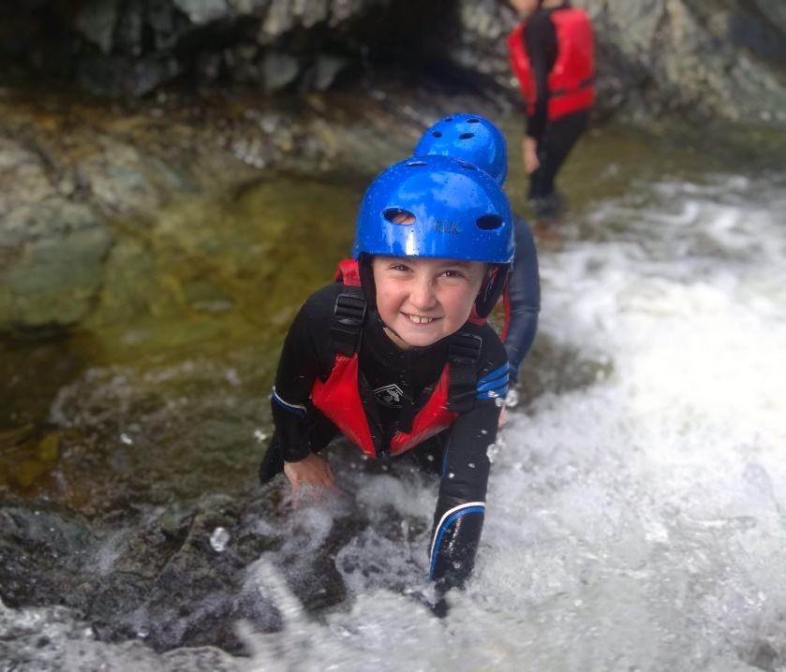
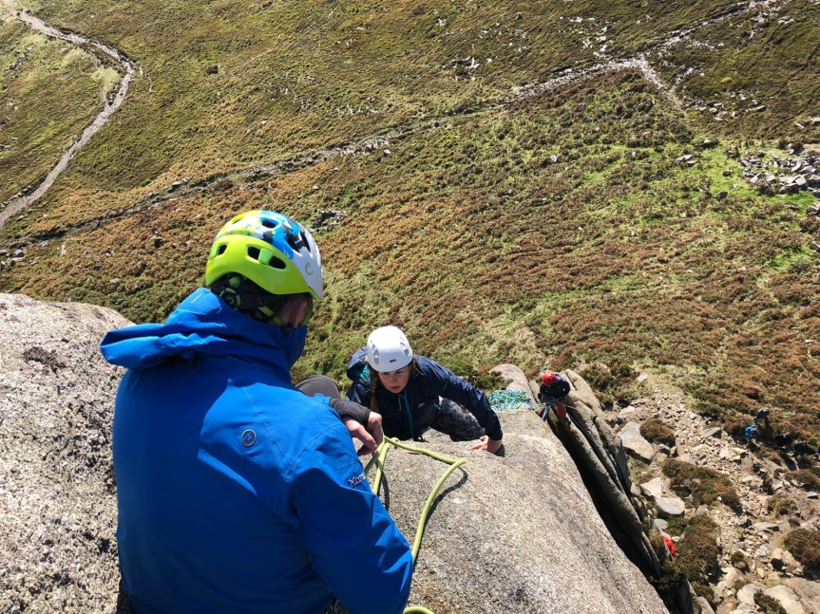
Last but not least, listen to your instructions, take loads of pictures for our facebook and Instagram and don’t forget to have a blast!

